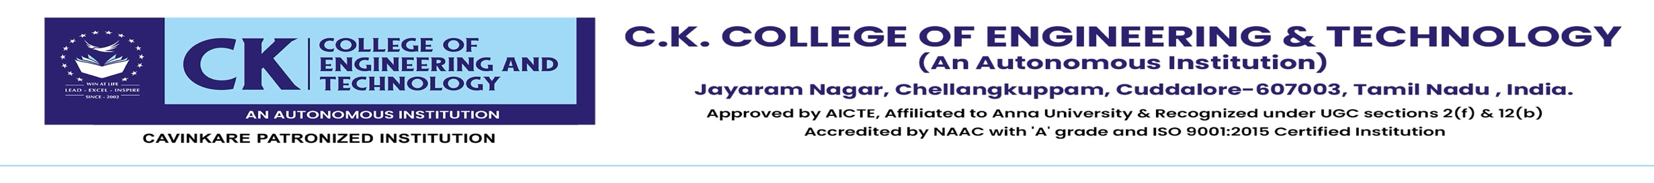
INTERNAL ASSESSMENT TEST – I
ACADEMIC YEAR – 2025 -26
Registration Number
Degree |  |  |  | Branch
Course Code & Title
Year / Semester |  | I/II |  |  | Common for
Date |  | Session |  |  |  |  |  |  | Duration |  |  | 180 min |  |  | Max. Mark |  |  | 100

PART A (Answer All the Questions) 10 x 2 = 20 Marks
Q. No. | Question (s) | KL | CO | PI
1 |  | L1 | CO1 | 1.7.1
2 |  | L1 | CO1 | 1.7.1
3 |  | L1 | CO1 | 1.1.1
4 |  | L2 | CO1 | 2.1.2
5 |  | L1 | CO2 | 1.7.1
6 |  | L2 | CO2 | 1.7.1
7 |  | L1 | CO2 | 2.1.2
8 |  | L2 | CO2 | 5.2.2
9 |  | L1 | CO3 | 1.4.1
10 |  | L1 | CO3 | 1.4.1
Part B (Answer All the Questions) 5 x 16 = 80 Marks
Q. No. | Question (s) | KL | CO | PI
11 (a) |  | L3  L3 | CO1 | 2.1.2  2.4.1
(OR)
11 (b) |  | L4  L3 | CO1 | 1.7.1  2.1.3
12 (a) |  | L3  L3 | CO1 | 1.7.1  2.4.1
(OR)
12 (b) |  | L4 | CO1 | 1.7.1
13 (a) |  | L3  L3 | CO2 | 1.7.1  2.1.2
(OR)
13 (b) |  | L4 | CO2 | 1.7.1
14 (a) |  | L3 | CO2 | 5.2.2
(OR)
14 (b) |  | L4 | CO2 | 5.2.2
15 (a) |  | L4 | CO3 | 4.1.2
(OR)
15 (b) |  | L3 | CO3 | 4.6.4

 | Name | Signature
Prepared by
Faculty In charge
Verified by
Academic Coordinator
Approved by
Head of the Department

Details of Course Outcomes
Course Outcome Code | Description | Tick the CO’s covered in this QP | Weightage of marks allotted to each CO
CO1
CO2
CO3
CO4
CO5

Audited by IQAC Member

